

|  |
| --- |
| **Title: Implementation of Quick sort/Merge sort algorithm** |



**Objective:** To learn the divide and conquer strategy of solving the problems of different types



**CO to be achieved:**

|  |  |
| --- | --- |
| Sr. No | Objective |
| CO 1 | Compare and demonstrate the efficiency of algorithms using asymptotic complexity notations. |
| CO 2 | Analyze and solve problems for divide and conquer strategy, greedy method, dynamic programming approach and backtracking and branch & bound policies. |
| CO 3 | Analyze and solve problems for   different string matching algorithms. |



**Books/ Journals/ Websites referred:**

1. **Ellis horowitz, Sarataj Sahni, S.Rajsekaran,” Fundamentals of computer algorithm”, University Press**
2. **T.H.Cormen ,C.E.Leiserson,R.L.Rivest and C.Stein,” Introduction to algortihtms”,2nd Edition ,MIT press/McGraw Hill,2001**
3. **http://en.wikipedia.org/wiki/Quicksort**
4. **https://www.cs.auckland.ac.nz/~jmor159/PLDS210/qsort.html**
5. **http://www.cs.rochester.edu/~gildea/csc282/slides/C07-quicksort.pdf**
6. **http://www.sorting-algorithms.com/quick-sort**
7. **http://www.cse.ust.hk/~dekai/271/notes/L01a/quickSort.pdf**
8. **http://en.wikipedia.org/wiki/Merge_sort**
9. **http://www.personal.kent.edu/~rmuhamma/Algorithms/MyAlgorithms/Sorting/mergeSort.htm**
10. **http://www.sorting-algorithms.com/merge-sort**
11. **http://www.princeton.edu/~achaney/tmve/wiki100k/docs/Merge_sort.html**



**Pre Lab/ Prior Concepts:**

Data structures, various sorting techniques



**Historical Profile:**

**Quicksort and merge sort are s a** divide**-**and-conquer sorting algorithm in which division is dynamically carried out. They are one the most efficient sorting algorithms.



**New Concepts to be learned:**

Number of comparisons, Application of algorithmic design strategy to any problem, Classical problem solving Vs Divide-and-Conquer problem solving.



**Algorithm** **Recursive Quick Sort:**

**void** quicksort( Integer A[ ], Integer left, Integer right)

**//**sorts A[left.. right] by using partition() to partition A[left.. right], and then //calling itself // twice to sort the two subarrays.

{ **IF** ( left < right ) then

{ q = partition( A, left, right);

quicksort( A, left, q–1);

quicksort( A, q+1, right);

}

}

**Integer *partition( integer A*T[], Integer *left*, Integer *right*)**

*//This function*rarranges *A*[*left***..***right*] and finds and returns an integer *q*, such that *A*[*left*], ..., //*A*[*q*–1] **<**∼ *pivot*, *A*[*q*] = *pivot*, *A*[*q*+1], ..., *A*[*right*] > *pivot*, where *pivot* is the first element of //a[left..right], before partitioning**.**

{

pivot = A[left]; lo = left+1; hi = right;

**WHILE** ( lo ≤ hi )

{ **WHILE** ( A[hi] > pivot ) hi = hi – 1;

**WHILE** ( lo ≤ hi and A[lo] <∼pivot ) lo = lo + 1;

**IF** ( lo ≤ hi ) then swap( A[lo], A[hi]);

}

swap( pivot, A[hi]);

**RETURN** hi;

}

**The space complexity of QuickSort:**

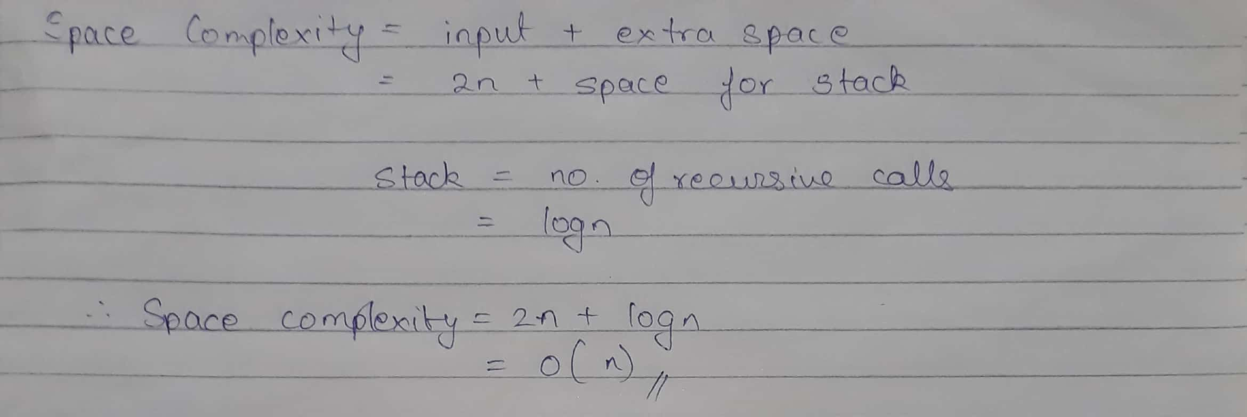

**Derivation of best case and worst case time complexity (Quick Sort)**

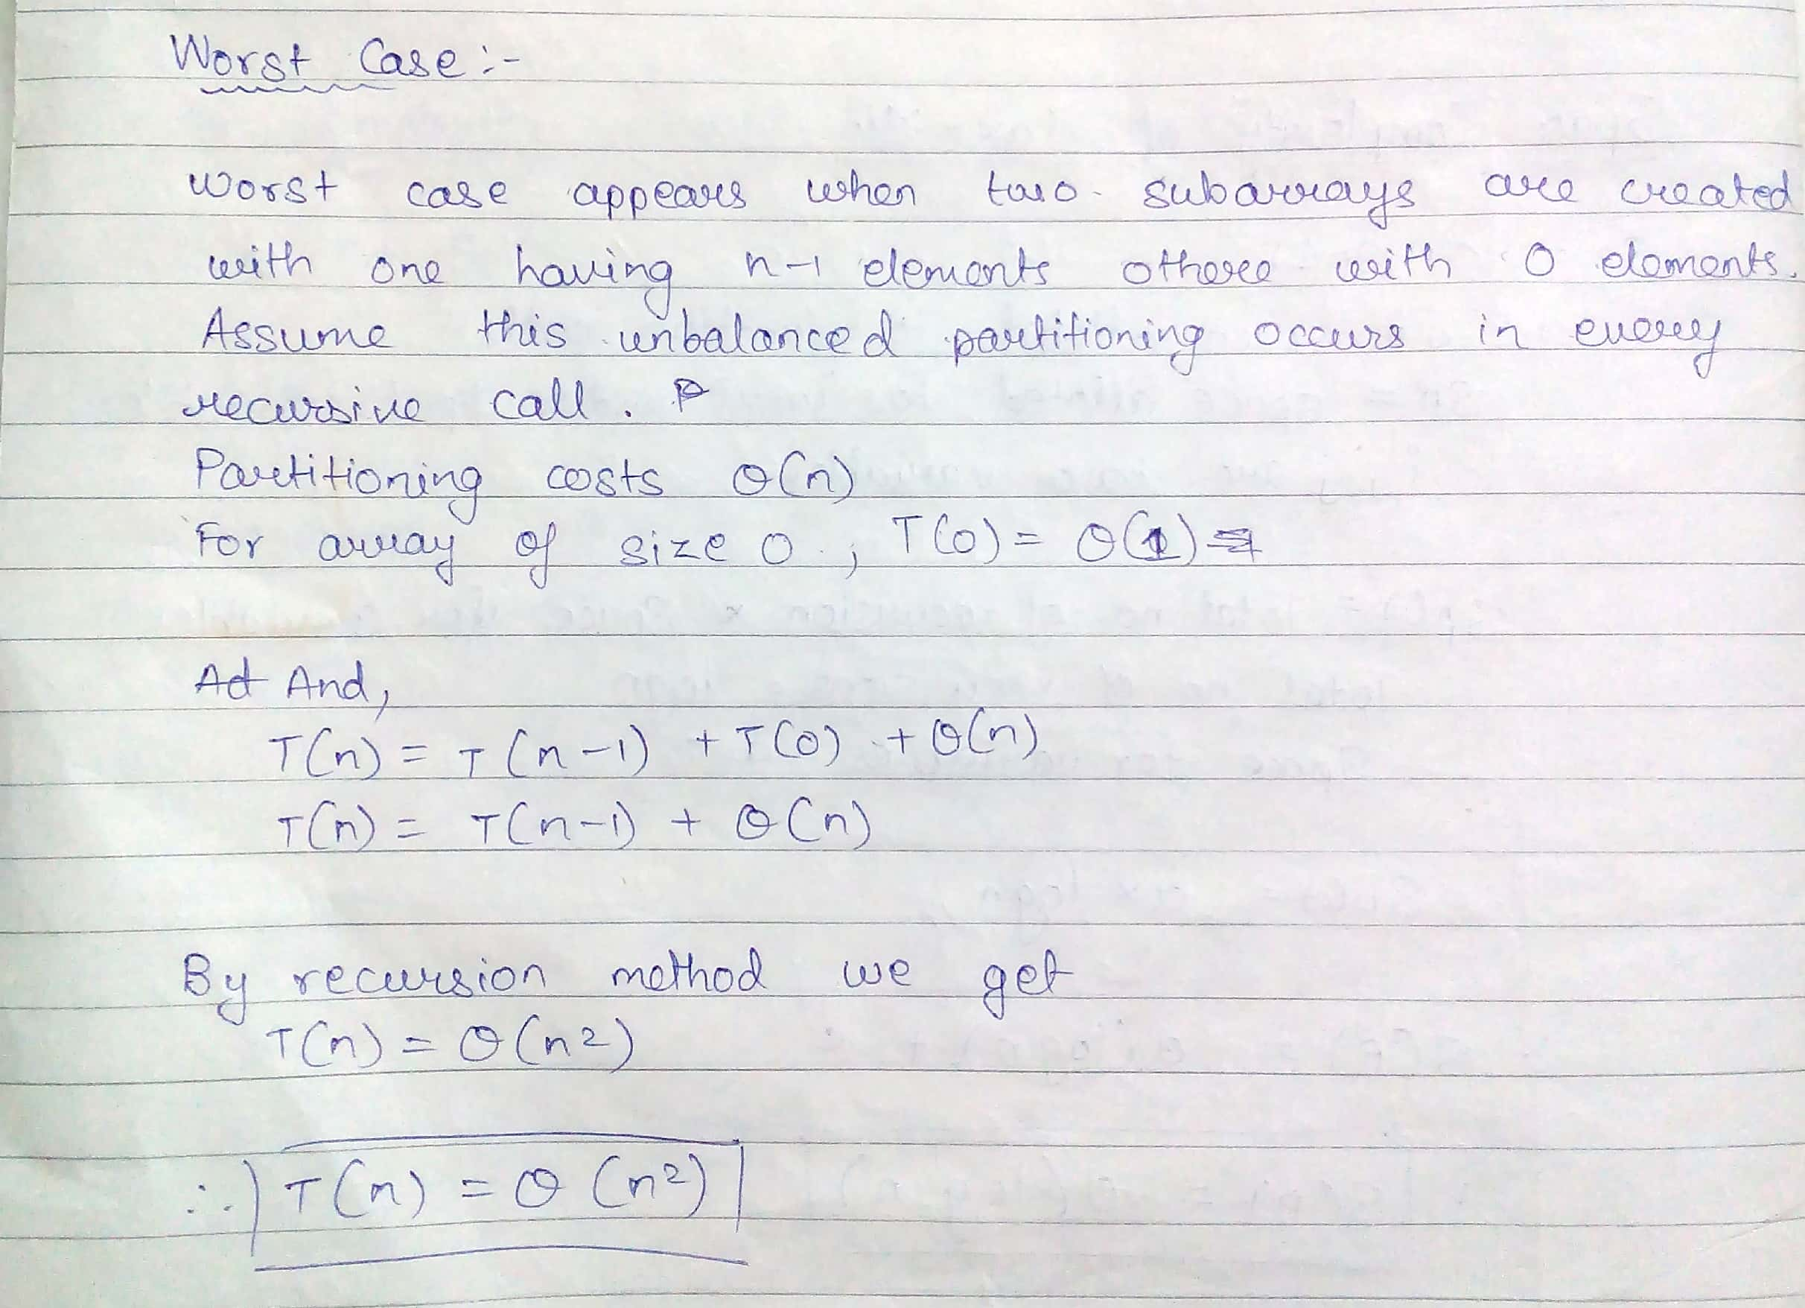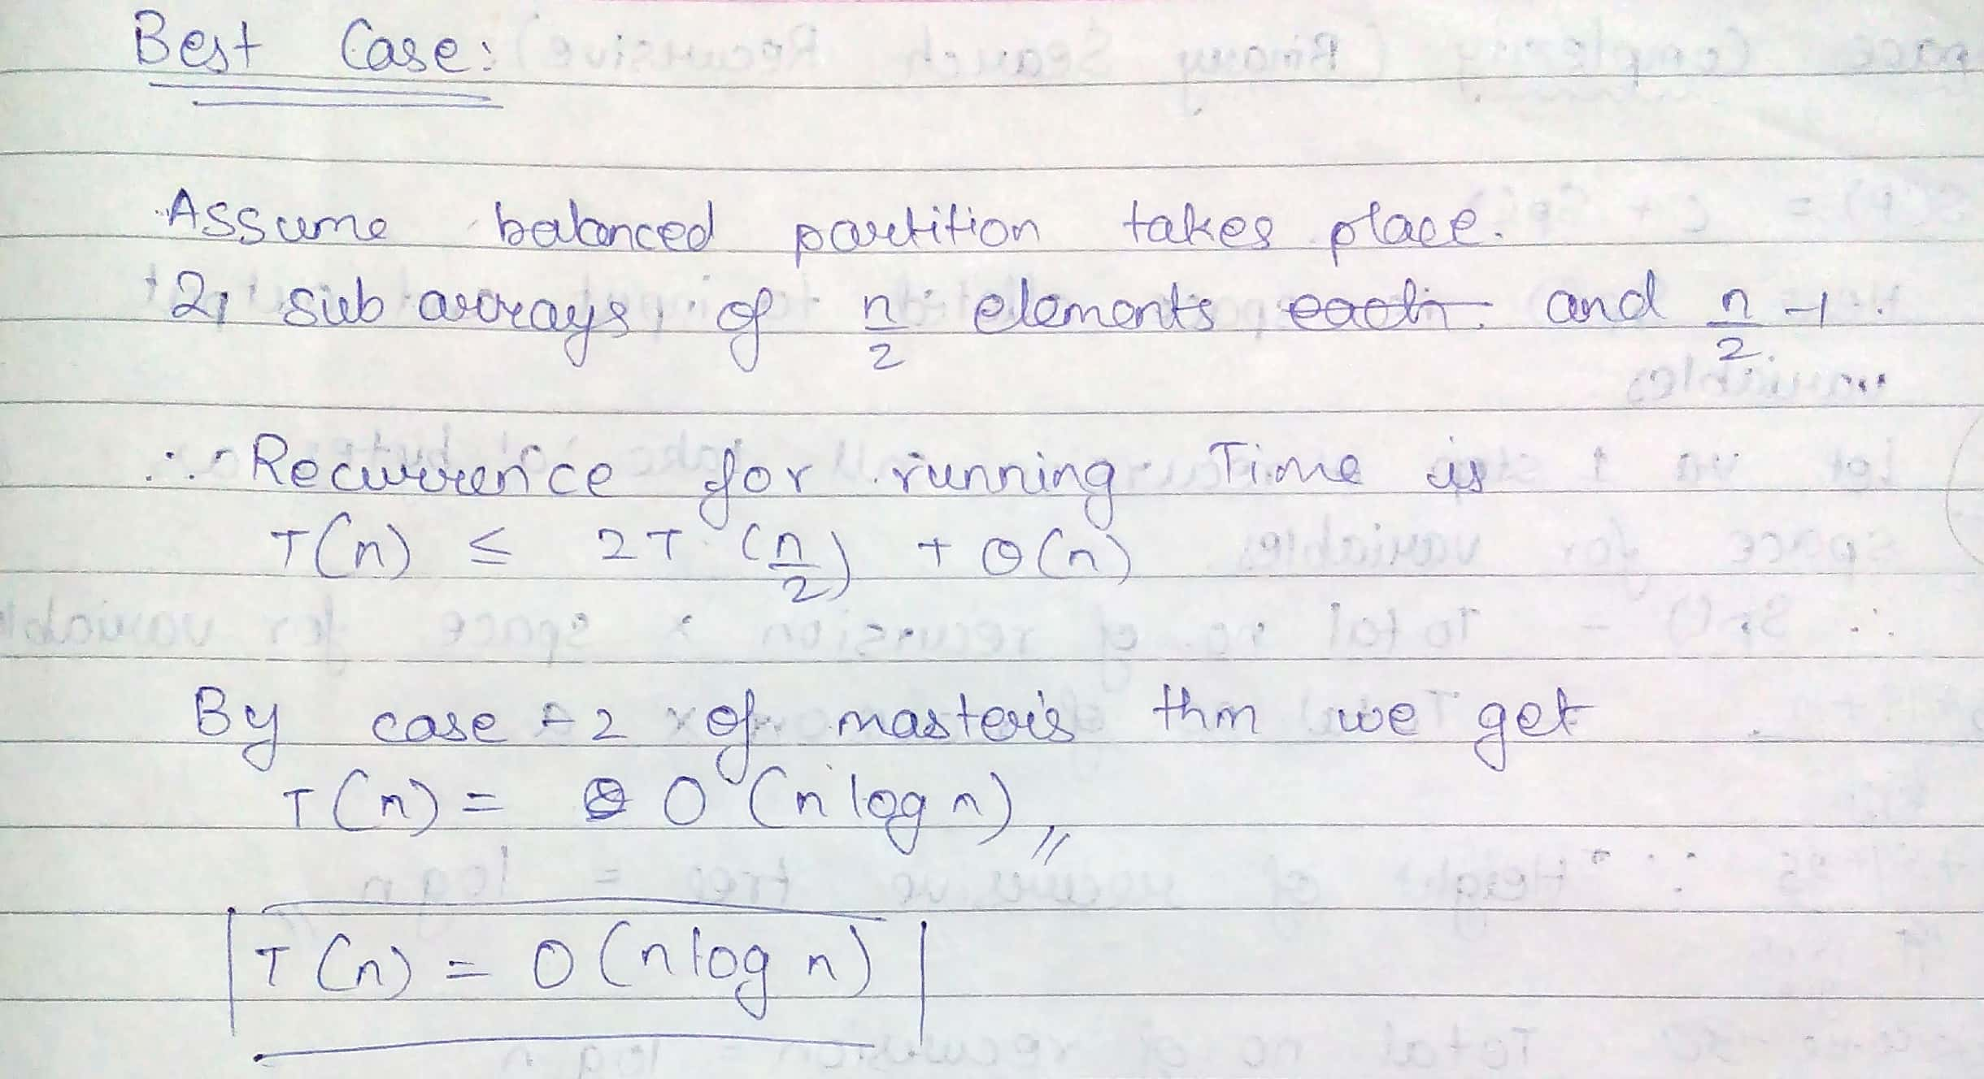

**Algorithm MergeSort**

MERGE-SORT (*A*, *p*, *r*)

// To sort the entire sequence A[1 .. n], make the initial call  to the procedure MERGE-SORT (*A*, //1, *n*). Array *A* and indices *p*, *q*, *r* such that *p* ≤ *q* ≤ r and subarray *A*[*p* .. *q*] is sorted and subarray //*A*[*q* + 1 .. *r*] is sorted. By restrictions on *p*, *q*, *r*, neither subarray is empty.

**//OUTPUT**: The two subarrays are merged into a single sorted subarray in *A*[*p* .. *r*].

**IF** *p* < *r*                                                    // Check for base case  
         **THEN** *q* = FLOOR[(*p* + *r*)/2]                 // Divide step  
                 **MERGE** (A, *p*, *q*)                          // Conquer step.  
                 MERGE (A, *q* + 1, *r*)                     // Conquer step.  
                 MERGE (A, *p*, *q*, *r*)                       // Conquer step.

MERGE (*A*, *p*, *q*, *r* )

{

*n*1 ← *q* − *p* + 1  
      *n*2 ← *r* − *q*  
      Create arrays L[1 . . *n*1 + 1] and R[1 . . *n*2 + 1]  
      **FOR** *i* ← 1 **TO** *n*1  
            **DO** L[*i*] ← A[*p* + *i* − 1]  
      **FOR** *j* ← 1 **TO** *n*2  
            **DO** R[*j*] ← A[*q* + *j* ]  
      L[*n*1 + 1] ← ∞  
      R[*n*2 + 1] ← ∞  
    *i* ← 1  
    *j* ← 1  
    **FOR** *k* ← *p* **TO** *r*  
         **DO IF** L[*i* ] ≤ R[ *j*]  
                **THEN** A[*k*] ← L[*i*]  
                        *i* ← *i* + 1  
                **ELSE** A[k] ← R[j]  
                        *j* ← *j* + 1

}

**The space complexity of Merge sort:**

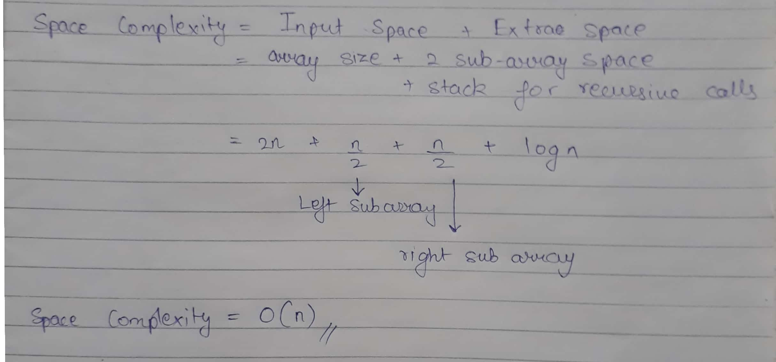

**Derivation of best case and worst case time complexity (Merge Sort)**

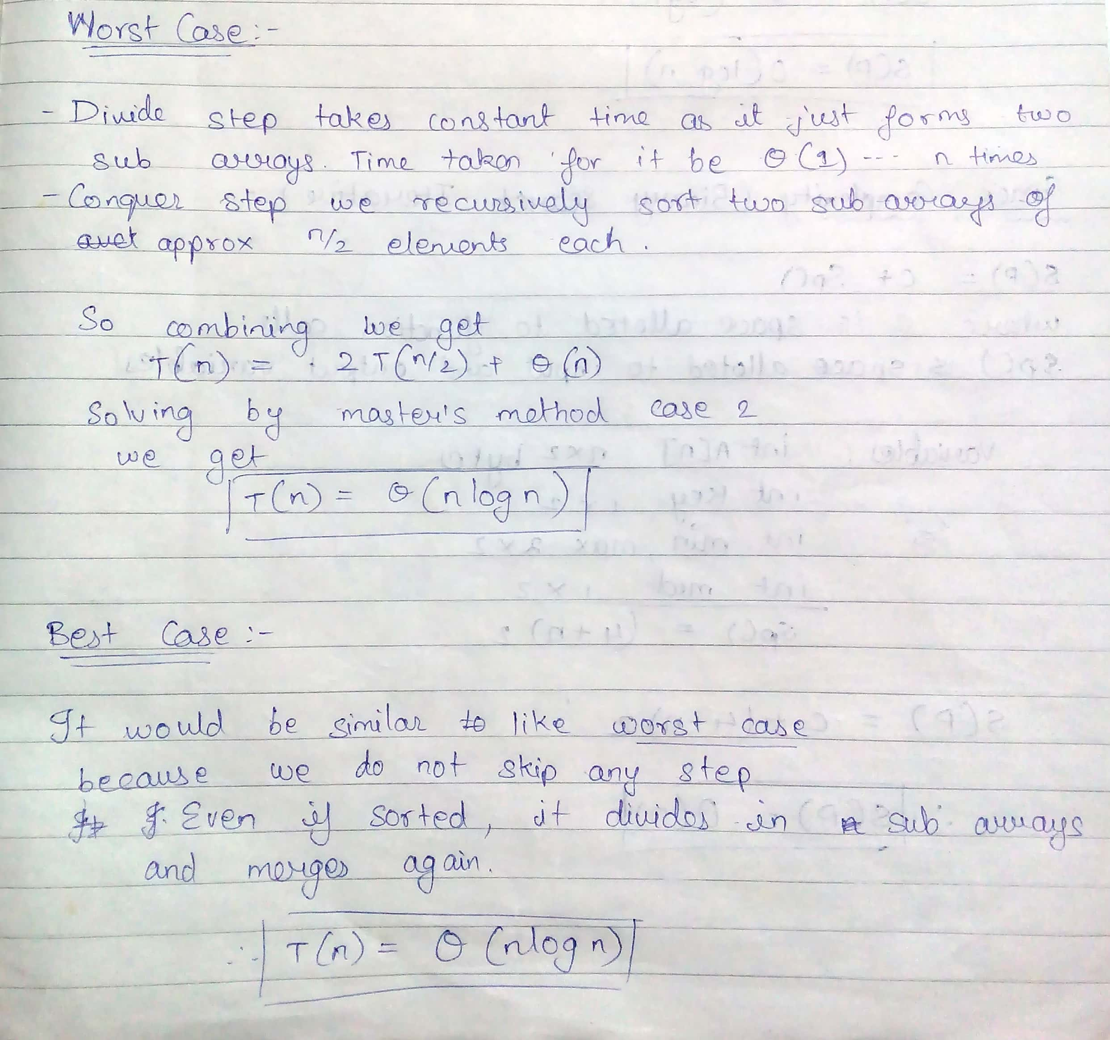

**Example for quicksort/Merge tree for merge sort:**

**MergeSort-Basic Example:**

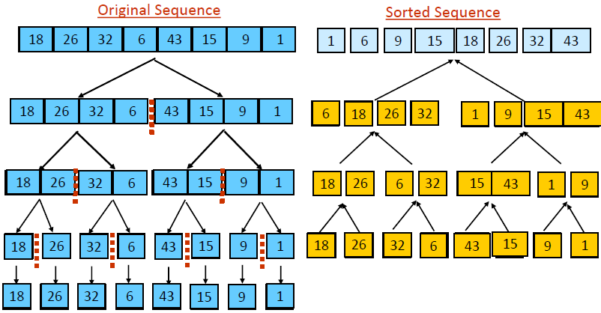

**CONCLUSION:**

Therefore, divide and conquer strategy and its applications are studied and a program for the implementation merge sort and quick sort have been implemented using this strategy. Further, the time and space complexity of the algorithms of the above mentioned programs was also calculated.